Role of World Bank in Global Economy
According to the World Bank’s web site:
The World Bank Group has set two goals for the world to achieve by 2030:
- End extreme poverty by decreasing the percentage of people living on less than $1.90 a day to no more than 3%
- Promote shared prosperity by fostering the income growth of the bottom 40% for every country
The World Bank is not a bank in the ordinary sense but a unique partnership to reduce poverty and support development. The World Bank Group comprises five institutions managed by their member countries.
Historically, the World Bank’s primary role in development seems to be in promoting free-market pathways to development, focusing primarily on GDP growth as the most important indicator of development. However, more recently there has been more of an emphasis on poverty alleviation and and improving social development, as well as making countries resilient to global challenges such as climate change and pandemics. .

Donor Countries and Countries viable for World Bank Assistance
The World Bank is funded primarily by the governments of the world’s richest 60 developed nations, and the amount each country provides is broadly related to its GDP – the USA is the largest donor, for example, having contributed $1.5 billion, while the UK is third, with a contribution of just under $900 million (2010 figures). NB It’s worth noting that the amount of money channeled through the World Bank is increasing.
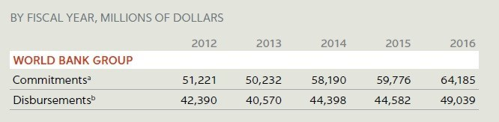
This means that the remaining 130 countries, mostly outside of Europe, are eligible for development aid through the World Bank.
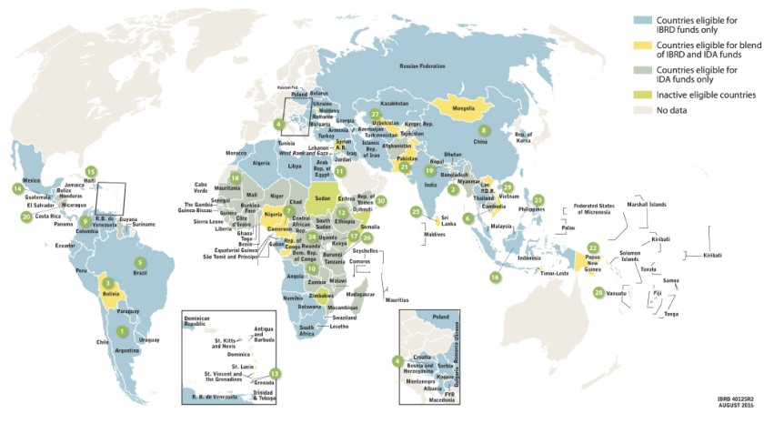Countries eligible for World Bank Assistance 2016

The Scale Development Assistance Given by the World Bank
In 2016 the World Bank made over $64 billion dollars of commitments to developing countries, broken down by region below (World Bank Annual Report, 2016)
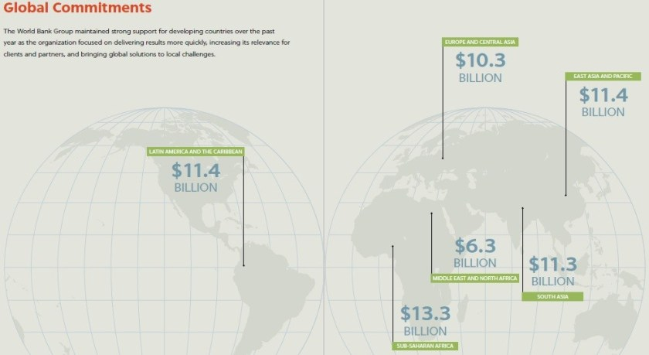

So what does the World Bank actually do to promote development?
TBH it’s difficult to say – exactly what the World Bank does in each country depends, to an extent, on that country’s level of development. To check out what the World Bank does in each country, and for progress, see the World Bank’s country pages.

Historically, the World Bank has had a Neoliberal Development Agenda
Despite there being different development programmes in different countries, since the 1980s, the World Bank has generally favoured a neoliberal approach to development by offering loans only if developing countries adopt neoliberal policies such as the privatization of public services, deregulation, lowering taxation, and developing an export-driven (rather than a subsistence) economy (Chapman et al, 2016).

The World Bank and Structural Adjustment Programmes (SAPs)
Structural Adjustment Programmes (SAPs) are one of the main policy vehicles through which the World Bank and the IMF* have sort to encourage economic development in poorer countries. They basically involve encouraging poorer countries to adopt a neoliberal pathway to development, favoouring free-trade.
Structural Adjustment Programmess were first introduced by the World Bank and the IMF in the 1980s in response to a debt crisis in Africa in the 1970s. Under SAPs, countries are able to get loans from the IMF or the World Bank if they accept conditions, which usually consist of adopting neoliberal policy reforms.

How did SAPs intend to fuel development?
SAPs required numerous developing countries to introduce the following neoliberal policies, which favoured free-market capitalism.
- Lower taxation, especially on profits – to provide incentives businesses and attract international investment.
- Privatisation of public services – neoliberals believe that state run services (such as health and education) are inefficient, privatising them means handing them over to private companies to run, which should deliver better services for cheaper because they’re more concerned with cost-cutting to maintain and increase profit.
- Deregulation – which included reducing the rules surrounding minimum wages, environmental legislation and health and safety, all of which make it more difficult to do business.
- Refocusing the economy to favour production for export rather than ‘import substitution’ – many SAPs encouraged developing countries to invest money in ‘export processing zones’ which were special areas (typically near ports) which TNCs could move into to manufacture goods cheaply for export, taking advantage of the cheap labour in poorer countries, rather than spending money supporting smaller, local industries producing goods for domestic consumption. A good example of this is provided through the current case study of Malawi. The World Bank’s web site says: ‘With support from the World Bank and other donors, the Malawi government has been developing a new national agricultural policy to refocus smallholder subsistence farming to commercial approaches’.

So What is the role of the World Bank in International Development?
Historically we can certainly say that the World Bank has made considerable efforts to support free-market capitalism, and some of its policies do seem have benefited some developing countries, such as the IDA graduates.
However, unfortunately for the World Bank, there is a lot evidence that many of its policies have not helped developing countries at all and numerous critics argue that its interventions in poor countries have actually made things worse for a lot of people,

